Broad Steps for Server Changeover (say 2008 -> 2012)
- Install Windows Server 2012 on new PC. Make Windows Server name SERVER2008x (explanation in next section)
- Install SQL Server 2008. So SQL Server Instance would be SERVER2008x\SQL_SERVER_2008.
- Backup the database. Test the program by editing the ini file in BackOffice to point to above instance name
- Test the program / masters / transactions / reports / images
- Create same shares as current main server (explained in later section)
- Copy latest database onto new server
- Copy D: and E: from current server
- Copy Desktop\Backups folder from current server
- ===================
- Unplug new server SQL Server 2012 from network
- Change Server name to SERVER2008 from SERVER2008x so that entire network does not have to make any changes (explanation in next section)
- Change SQL Server instance name
- Change the IP address of new server
- Change ini file in BackOffice
- Restore latest database
- Unplug old server and plug new server in its place
- Test BackOffice on new server
- Test BackOffice from network / masters / transactions / reports / images
- Create Maintenance and Job Plans
- ======================
- Change Old Server name to SERVER2008BKUP(explanation in next section)
- Change SQL Server instance name on SERVER2008BKUP
- Change the IP address of new server on SERVER2008BKUP
- Connect SERVER2008BKUP
- Change ini file in BackOffice to point to new Server

Change Windows Server name to SERVER2008
- Click on Start Button on bottom left hand side
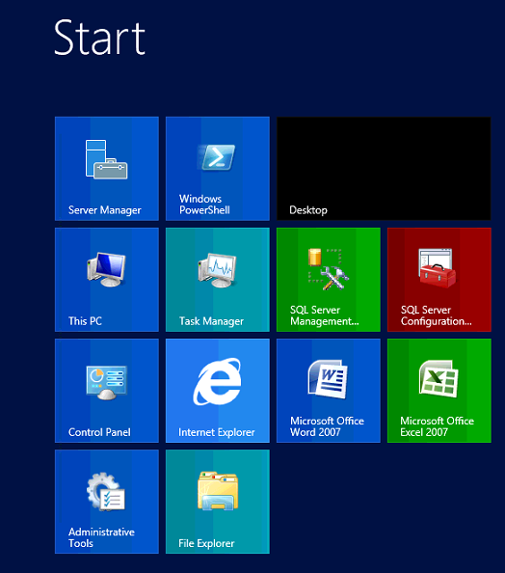
- Right Click on “This PC”-> Properties
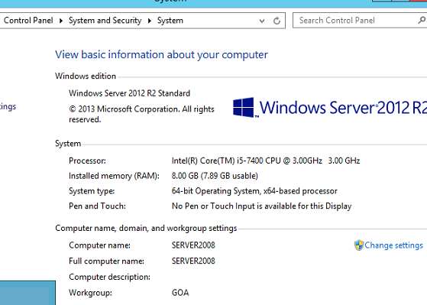
- Click on “Change Settings”
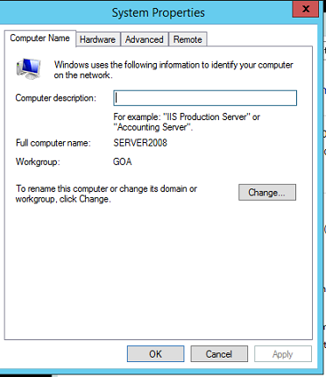
- Click on “Change”
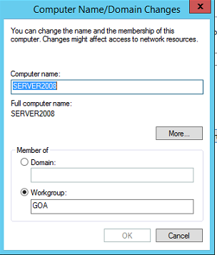
- Enter SERVER2008 -> OK -> OK
- Restart Server

Change IP address of the Current Server to match the old server
- Go to the Control Panel
- Network / Internet
- Change Adapter Settings
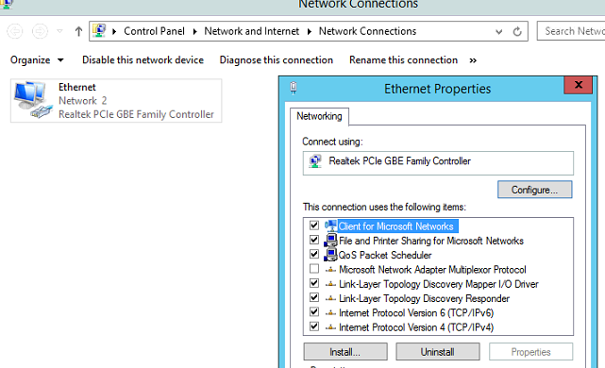
- Right Click -> Properties
- Internet Protocol Version 4 (TCP/IPv4)
- Click on Properties
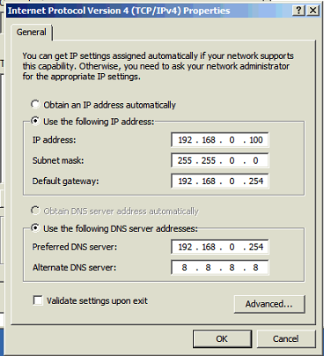
- For the backup server, set it as 192.168.0.99

If SQL Server 2008 was already installed
- Open SQL Server Management Studio (pinned at the bottom to the task bar)
- Make sure the server name is SERVER2008\SQL_SERVER_2008 (The new windows server name must be used)
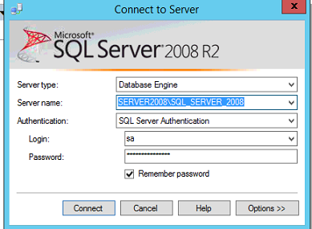
- Login ‘sa’, ‘sa123@pwd’ -> Connect
- select @@SERVERNAME. This will give the current instance with the old windows server name
- sp_dropserver 'SERVER2008_old\SQL_SERVER_2008'. Drop that instance
- sp_addserver 'SERVER2008\SQL_SERVER_2008', local. Add new instance
- Close SQL Server Management Studio
- Open SQL Server Configuration Manager (pinned at bottom to the task bar)
- Click on SQL Server Services
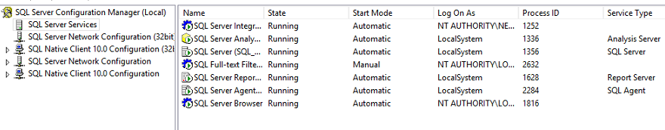
- Stop All Services (Right clicking on each service)
- Restart All Services (Right clicking on each service)
- Close SQL Server Configuration Manager
- Reopen SQL Server Management Studio
- select @@SERVERNAME. This should now show the updated instance

Create “SHARES” on Server
- Open File explorer
- Connect to backup server \\server2008bkup
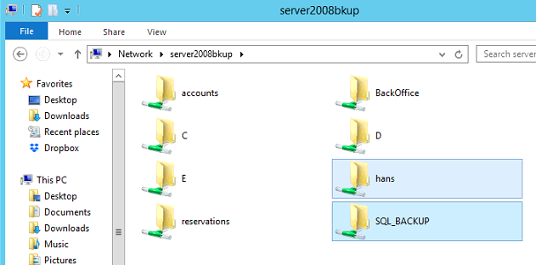
- Check out all the shares
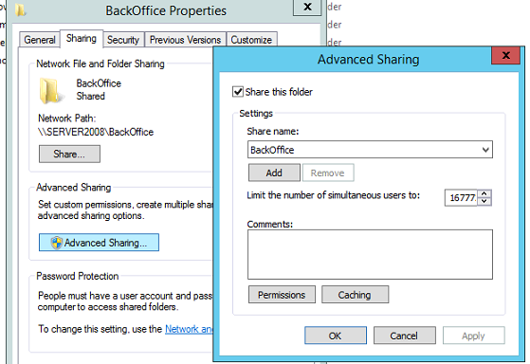
- Set the same shares on the new server
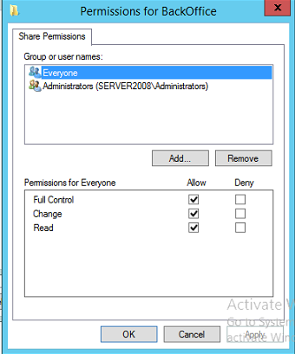

Installing SQL Server 2008 on Windows Server 2012
- Click on Start Button on bottom left hand side

- Right Click on “This PC”-> Manage
- Click on “Add Roles and Features”
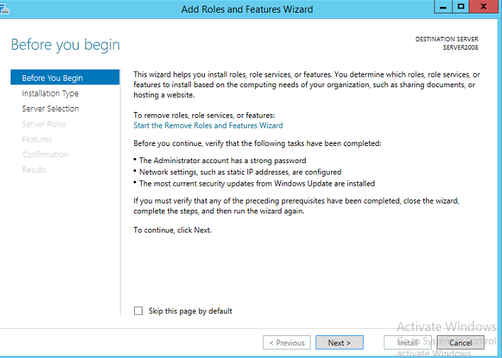
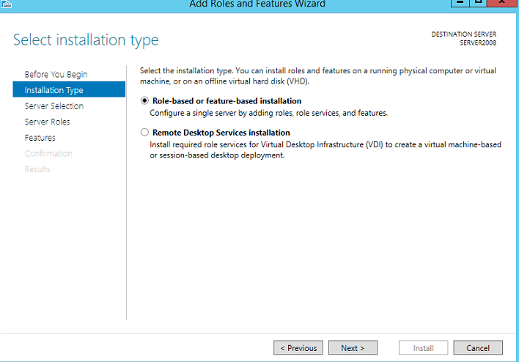
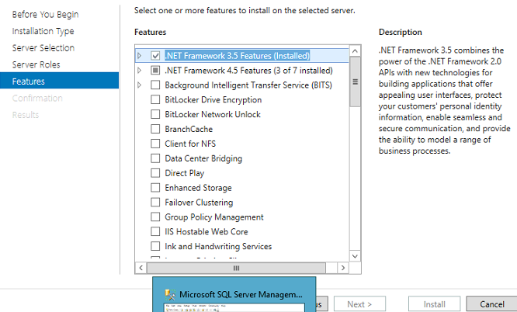
- Install .NET Framework 3.5 and 4.
- You may get a couple of errors while installing SQL Server 2008, but ignore them and proceed one you have installed the .NET framework

Installing SQL Server 2008
- On Windows Server 2008 D:\Installs\SQL Server 2008
- Check if Windows Server 2008 is 32 bit or 64 bit
- Change Server name to SERVER2008
- Double click on Setup
- Click on installation on the left panel

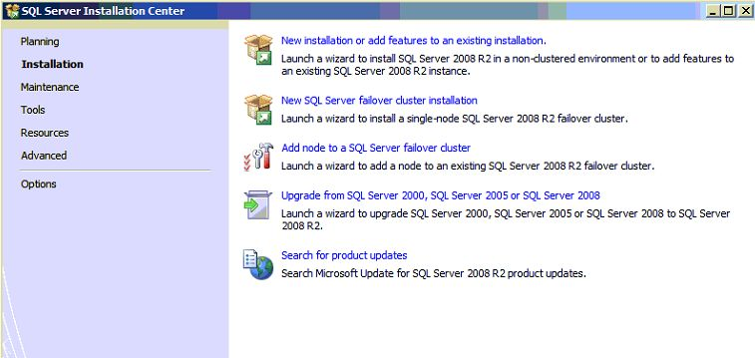

- Click on installation on the left panel
- Click on New Installation on the right panel
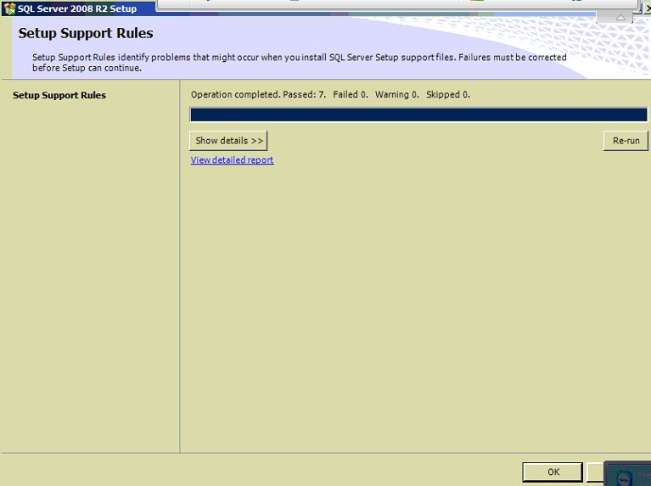
- Click on OK
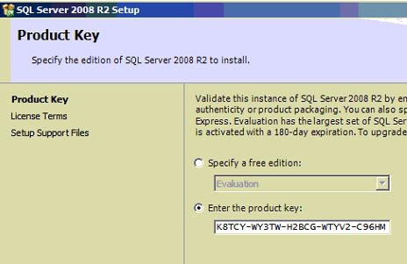
- Product key is entered automatically
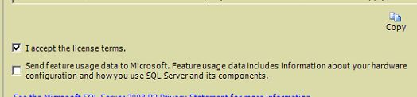

- Accept License Terms

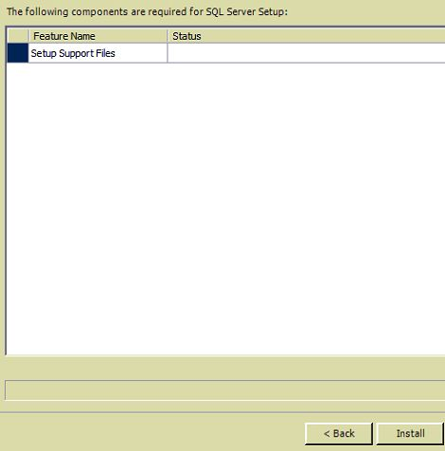
- Begin installation

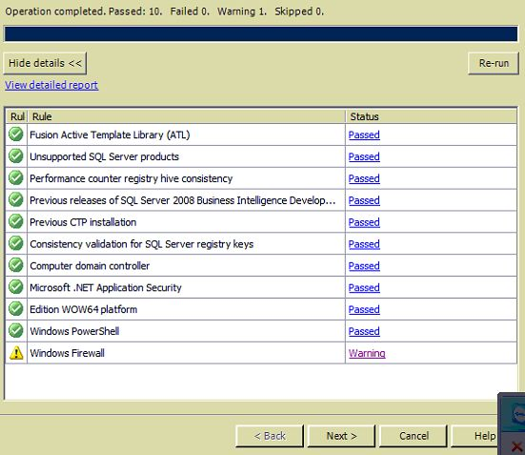
- Continue installation
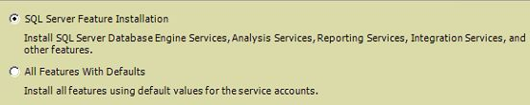

- Installation Type
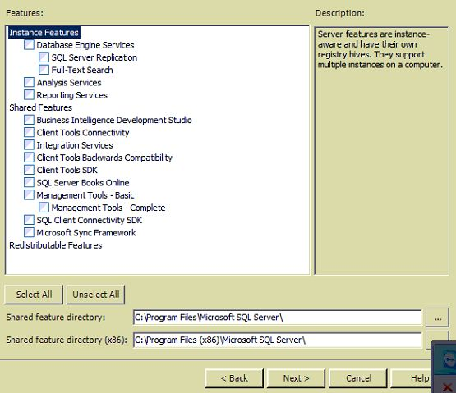

- Select All
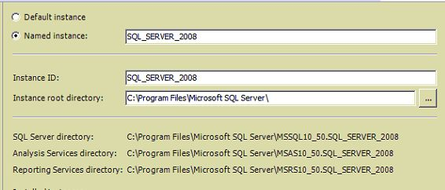

- Instance Name
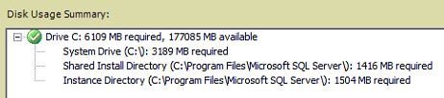

- Disk space available
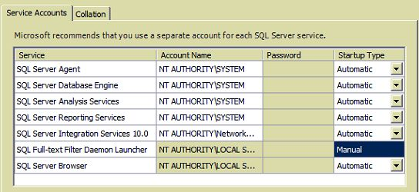
- Set Service Accounts & Collation (Careful – choose General_CP1_CI_AS – CI case insensitive)
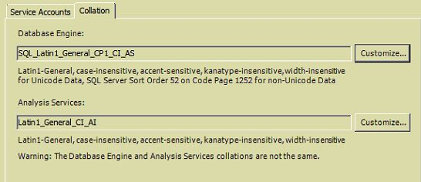

- Account Provisioning & Data Directories
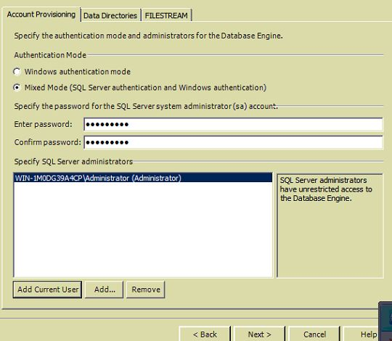

- Change Data & Backup directories by going to the Data Directories tab
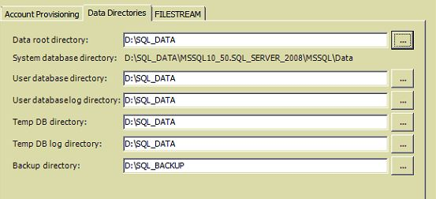

- Configuration
  - Password: sa123@pwd
  - Click on ‘Add Current User’
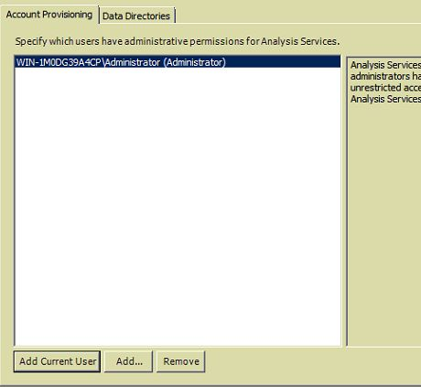

- Analysis Services Configuration
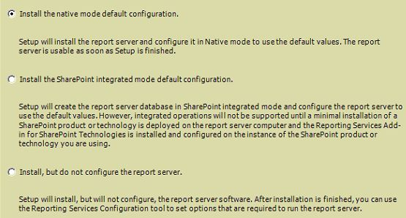

- Reporting Services
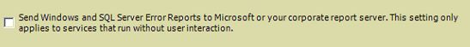

- Do not select ‘Send reports to Microsoft’

- Installation Configuration Rules -> Click Next
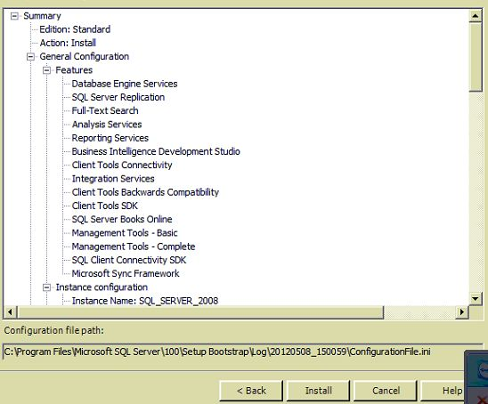

- Ready to Install

- After installation
  - Open Start Menu -> All Programs -> SQL Server 2008 R2 -> SQL Server Management Studio
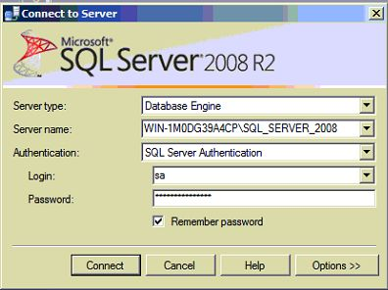

  - WIN-1M0DG39A4CP\SQL_SERVER_2008
  - Password: sa123@pwd
  - Right Click -> Properties -> Database Settings
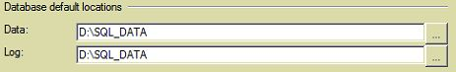

  - This sets D:\SQL_DATA as the default SQL Server Data Path (if not setup during installation)
  - Backup Data Path (if not setup during installation)
    - Start Menu -> Command Prompt -> regedit
    - HKEY_LOCAL_MACHINE\SOFTWARE\Microsoft\Microsoft SQL Server\MSSQL10_50.SQL_SERVER_2008\MSSQLServer
    - Right Click on ‘Backup Directory’ -> Modify
    - Change to D:\SQL_BACKUP

- Checks
  - SELECT DATABASEPROPERTYEX('tempdb', 'Collation')
  - SELECT DATABASEPROPERTYEX('tempdb', 'Collation'), SERVERPROPERTY ('Collation')
  - Should be COLLATE SQL_Latin1_General_CP1_CI_AS. CI stands for Case Insensitive

- Create Database
  - Right Click Databases -> New Database
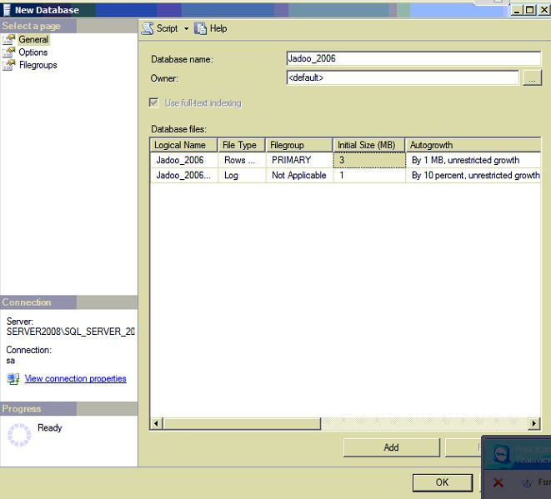

- Restore Database
  - Put the backup in D:\SQL_BACKUP
  - Click on Jadoo_2006
  - Right Click -> Tasks -> Restore -> Database
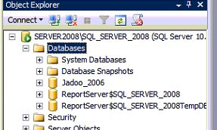

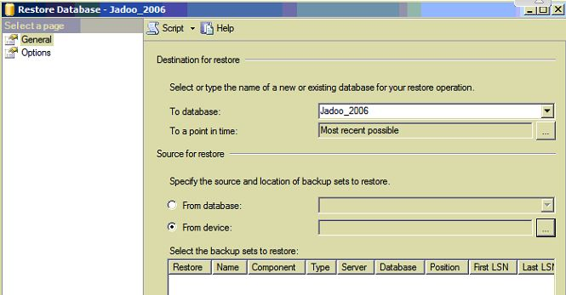

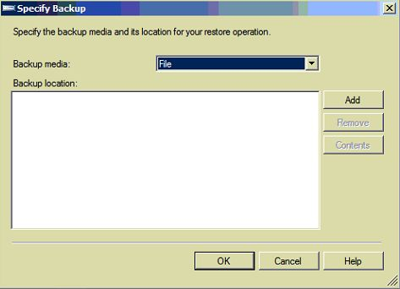

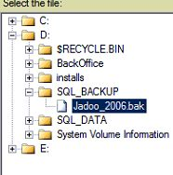

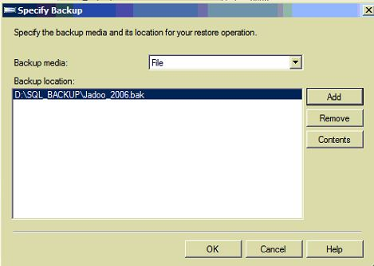

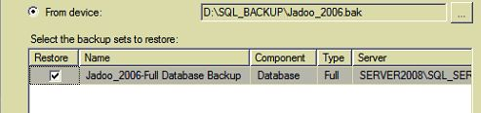

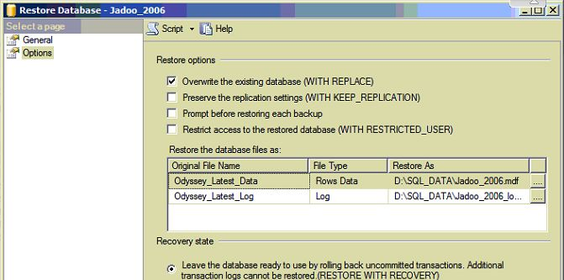

- For Connectivity to clients
  - Remove the windows firewall from the server. Go to the Control Panel and seach for Windows Firewall.
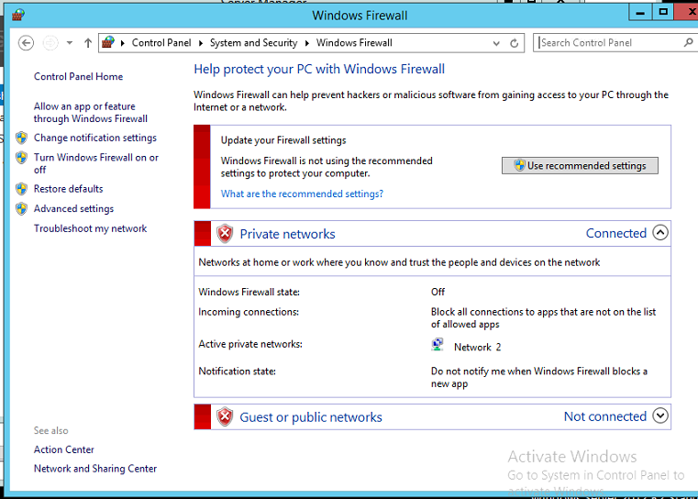
  - If the client has a problem, copy midas.dll from the BackOffice.exe directory on the server onto the C:\Windows\System32 directory of the client
  - Run regsvr midas.dll OR regsvr32 midas.dll
- Setup the gotomypc account on the server
- Add automated jobs on the server
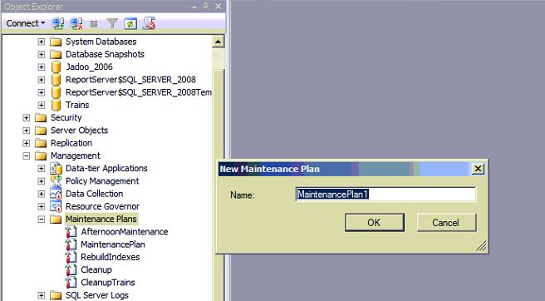

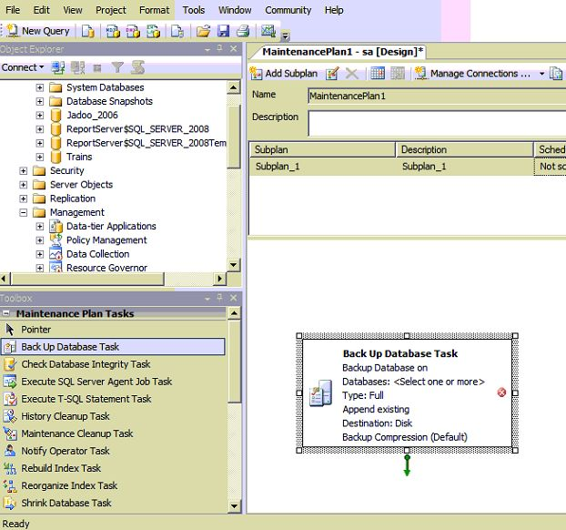

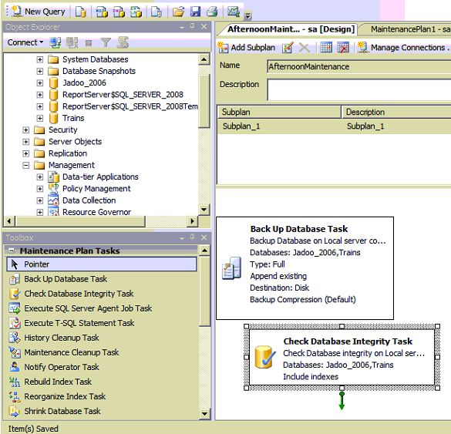

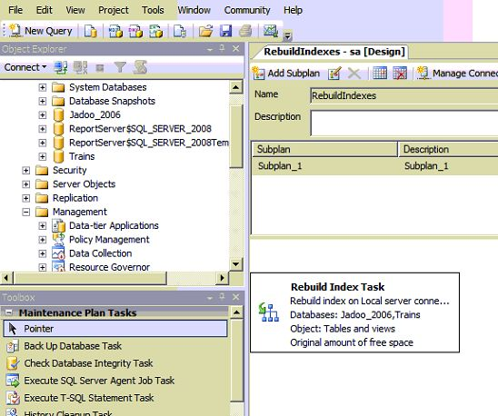

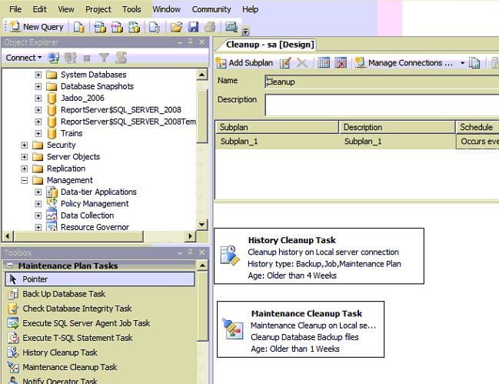

- Scheduling Backup tasks
  - My Computer -> Right Click -> Manage
  - Add Basic Task
  - Configure it to run C:\del.bat
    - Copies newer files to \\SERVER2003BKUP\SQL_BACKUP_2
    - Deletes files older than 7 days on the server
    - Deletes files older than 15 days on the backup server
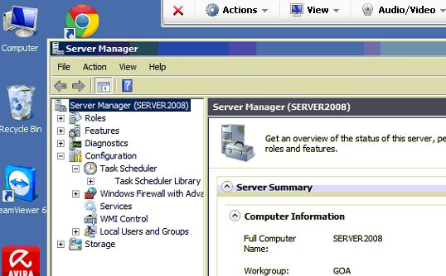

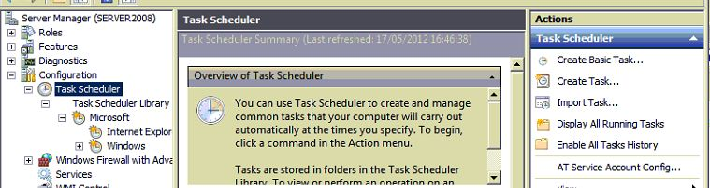

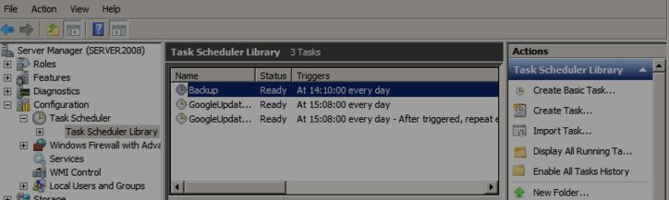

- Password protect server with screen saver
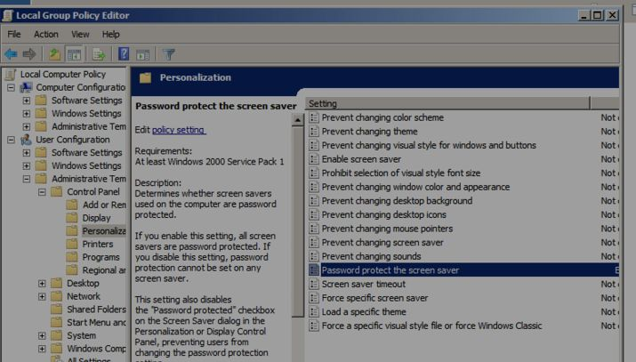

Backup Jobs Schedule

- 08:15 Job Daily Backup Jadoo_2006.bak
- 13:30 Job AfternoonMaintenance
- 14:00 Powershell Copy To Backup Server
- 20:15 Job Daily Backup Jadoo_2006.bak
- 20:30 Powershell Zip and DropBox Copy

Running Powershell Jobs
- Enable execution of scripts
- Open Powershell window “As Administrator”
- Type “Set-ExecutionPolicy RemoteSigned”
- Go to Desktop\ Backups\Db
- To execute powershell scripts from the directory they are located in .\xxxx.ps1

Scheduling Powershell Jobs in Server 2012
- Click on Start Button on bottom left hand side

- Right Click on “This PC”-> Manage
- On the menu on the top panel, click on Manage -> Task Manager
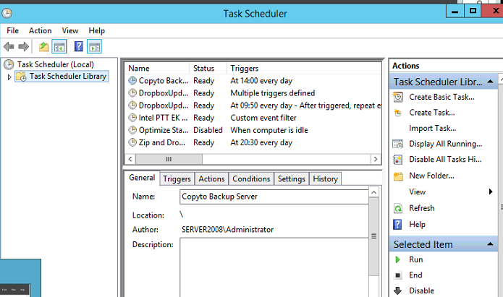
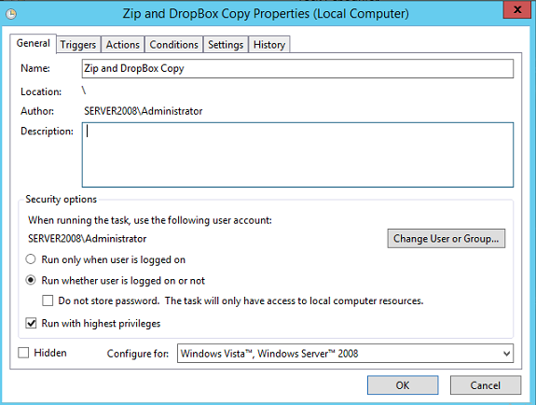
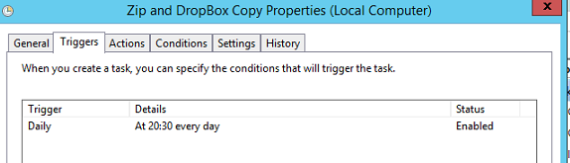
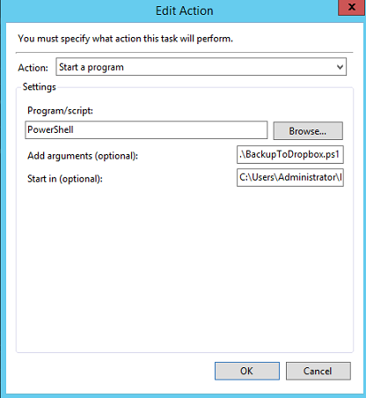
Start In: C:\Users\Administrator\Desktop\Backups\Db\
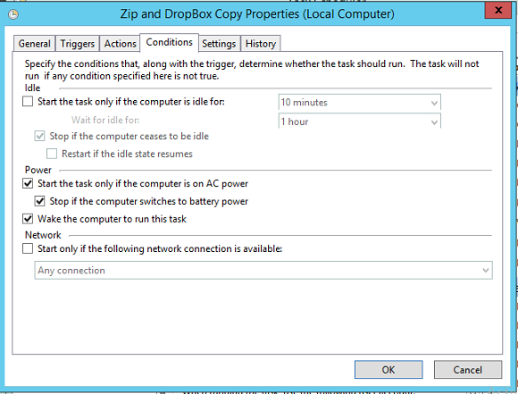
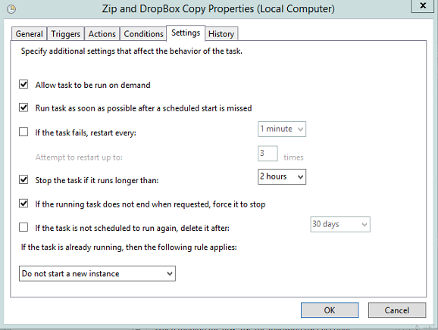
Enable History
